**SWORD FIGHTing AR GAME**

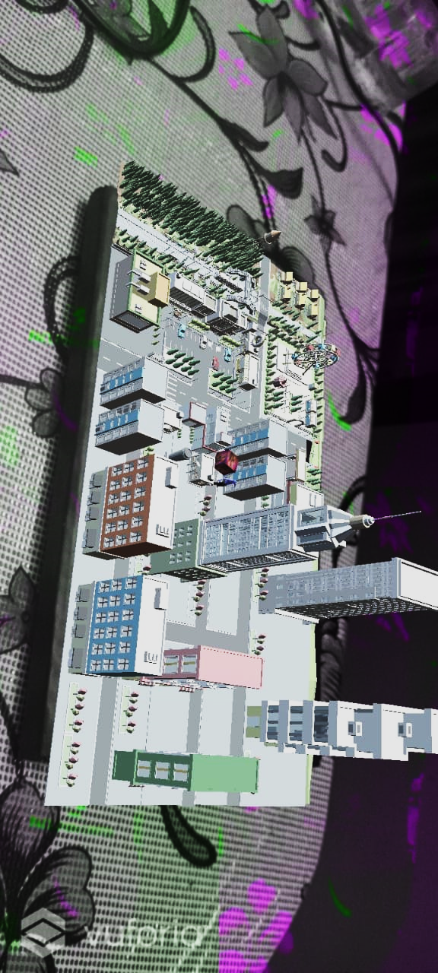

**TEAM MEMBERS:**

* **Akshay Singh**
* **Sanchit Sikri**
* **Shreya Attri**

**CONCEPT:**

**This game involves sword fighting with integrated AR experience. Augmented Reality (AR) is an interactive experience of a real-world environment where the objects that reside in the real world are enhanced by computer-generated perceptual information.AR can be defined as a system that incorporates three basic features: a combination of real and virtual worlds, real-time interaction, and accurate 3D registration of virtual and real objects.**

**GAMEPLAY:**

**The game involves a player having a sword and he has to simply kill the zombies that are coming towards to kill him. The zombies will come towards the player and he has to save him from his sword. There will be a city where all over only zombies are there and our player has to cross that city by killing all the zombies. There will be a total of 7 zombies roaming around in the whole city and the player has to kill all of them in order to complete the level. A timer will also be running and only in that specified time the player has to complete the whole game.**

**GAME CONSTRUCTION:**

* **We are using C# for the coding part of the game. With this we are controlling the movements, zombies, efficiency, force of the sword, collision, point board, game start, game over, and few others.**
* **We placed an image target using Vuforia engine on to the gamescene. Then we imported a map of the game on placed on the image target.**
* **Similarly we place player and zombies on the map and add scripts for their movement.**

**SCRIPTS:**

**There are several scripts of visual studios used to control the player movement, zombie movement and the AR system.**

**1) Player Movement Script:**

**In this script we have used animations and some inbuilt functions of unity like player controller, animator controller, player skeleton, animation rigging etc. We have also downloaded cinemachine for the better movement of our player. We have used boolean characters to control our animations. We have used the mouse to control the view of the player.**

**Script:**

using System.Collections;

using System.Collections.Generic;

using UnityEngine;

public class thirdpersonmovement : MonoBehaviour

{

public CharacterController controller;

public float speed = 6f;

public float turnSmoothTime = 0.1f;

float turnSmoothVelocity;

// Update is called once per frame

void Update()

{

float horizontal = Input.GetAxisRaw("Horizontal");

float vertical = Input.GetAxisRaw("Vertical");

Vector3 direction = new Vector3(horizontal, 0f, vertical).normalized;

if(direction.magnitude >= 0.1f)

{

float targetAngle = Mathf.Atan2(direction.x, direction.z) * Mathf.Rad2Deg ;

float angle = Mathf.SmoothDampAngle(transform.eulerAngles.y, targetAngle, ref turnSmoothVelocity, turnSmoothTime);

transform.rotation = Quaternion.Euler(0f, angle, 0f);

controller.Move(direction.normalized * speed * Time.deltaTime);

}

}

}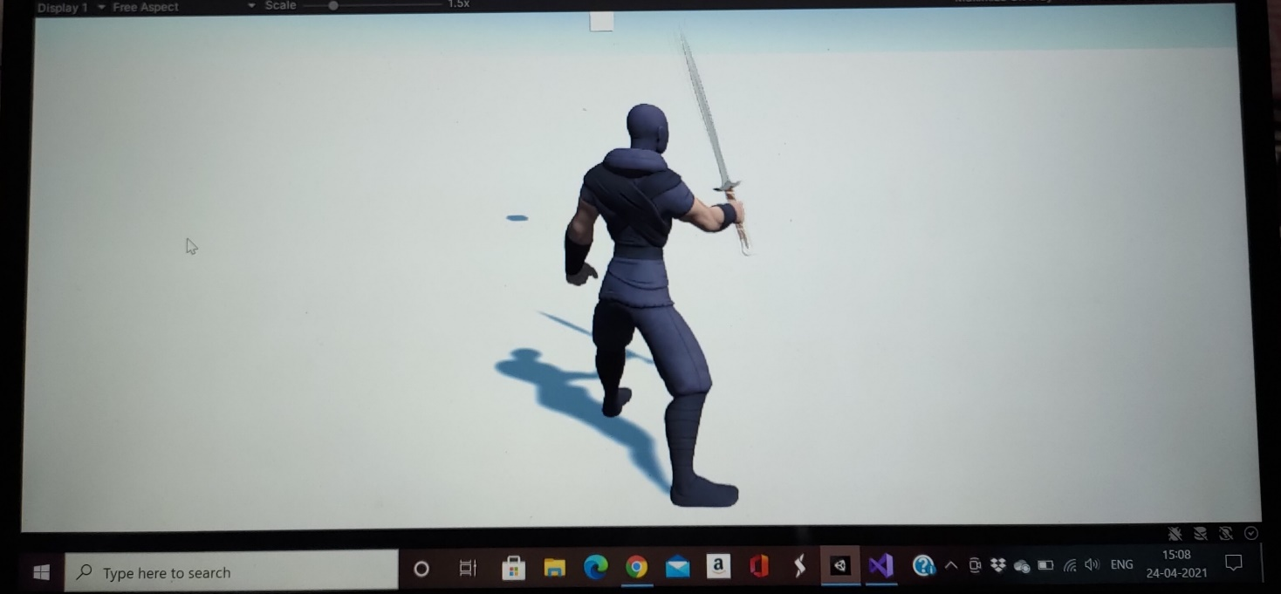

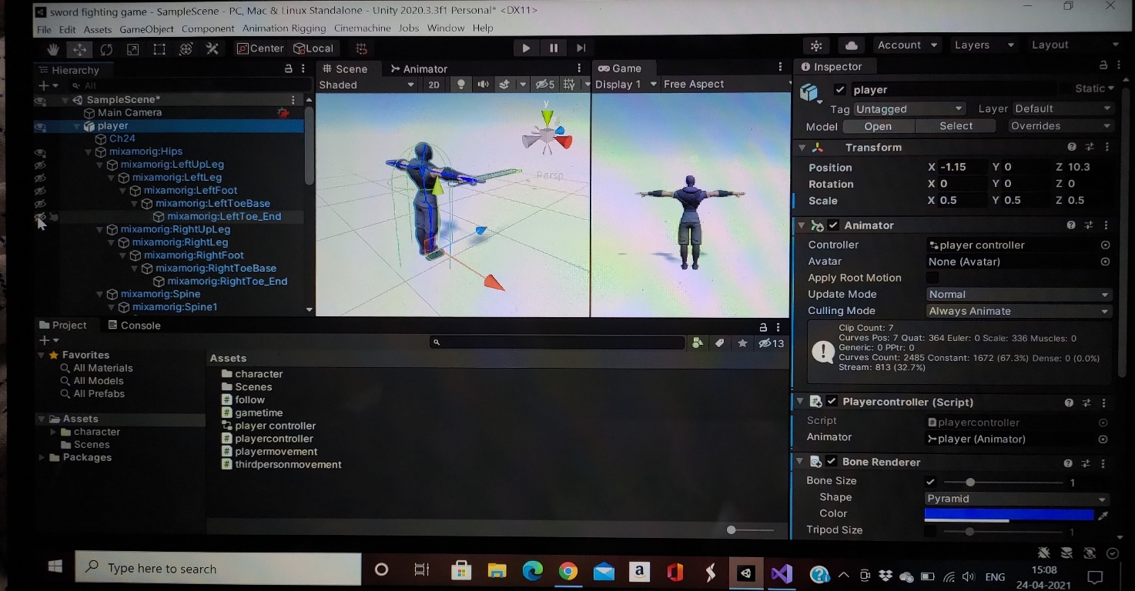

**2) Zombies script:**

**We have downloaded our characters and animations from the site mixamo. The zombies are desighed to hit the player to reduce its health and they get killed by players sword. For this interaction we have used the function of box collider. Also for the movement of the zombies cinemachine is used.**

**Script:**

using UnityEngine;

public class thirdpersonmovement : MonoBehaviour

{

public CharacterController controller;

public Transform cam;

public float speed = 6f;

public float turnSmoothTime = 0.1f;

float turnSmoothVelocity;

void Update()

{

float horizontal = Input.GetAxisRaw("Horizontal");

Vector3 direction = new Vector3(horizontal ,0f,0f).normalized;

if(direction.magnitude >= 0.1f)

{

float targetangle = Mathf.Atan2(direction.x, direction.z) * Mathf.Rad2Deg * cam.eulerAngles.y;

float angle = Mathf.SmoothDampAngle(transform.eulerAngles.y, targetangle, ref turnSmoothVelocity, turnSmoothTime);

transform.rotation = Quaternion.Euler(0f, angle, 0f);

Vector3 movdir = Quaternion.Euler(0f, targetangle, 0f) * Vector3.forward;

controller.Move(movdir * speed * Time.deltaTime);

}

}

}

**3) Health script:**

**Both the player and zombies will have this script. If any of them gets hit 3 times then on the 4th hit the player or zombie will get disappeared from the scene.**

**Script:**

using System.Collections;

using System.Collections.Generic;

using UnityEngine;

public class healthbar : MonoBehaviour

{

public float maxhealth = 100f;

public float curhealth = 0f;

// Start is called before the first frame update

void Start()

{

curhealth = maxhealth;

InvokeRepeating("decreasehealth", 1f, 1f);

}

// Update is called once per frame

void Update()

{

}

void decreasehealth()

{

curhealth -= 2;

}

}

**4) Attack script and damage scripts:**

**This script is for the player attack and damage on the zombies.**

**Scripts:**

using System.Collections;

using System.Collections.Generic;

using UnityEngine;

using UnityEngine.AI;

public class attack : MonoBehaviour

{

public NavMeshAgent enemy;

public Transform player;

void start()

{

}

void update()

{

enemy.SetDestination(player.position);

}

}

using System.Collections;

using System.Collections.Generic;

using UnityEngine;

public class damage : MonoBehaviour

{

public float Damage = 10f;

void OnTriggerEnter(Collider enemy)

{

enemy.gameObject.GetComponent<playerhealth>().TakeDamage(Damage);

}

}

**Gamescene:**

**We have incorporated a 3d model of a game scene from a site “sketchfab.com” to our AR project. We are referring to following tutorial for the script of placing the game scene to the project.**

**Tutorial link used:** [**https://youtu.be/mjNAPCFaZ9Y**](https://youtu.be/mjNAPCFaZ9Y)

**Game scene Image:**

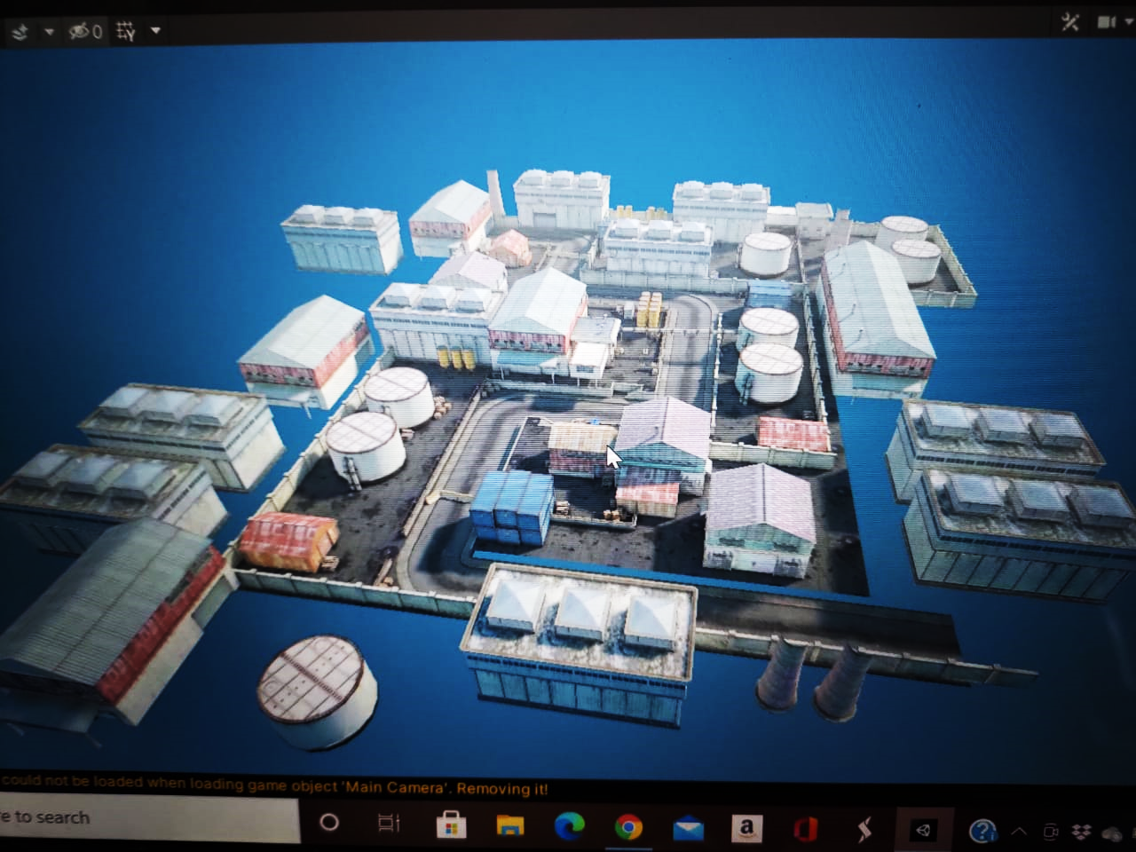

**Joystick and Attack Button:**

**We have added a joystick and attacking button on the screen of the mobile phone to control the player movements and attacks.**

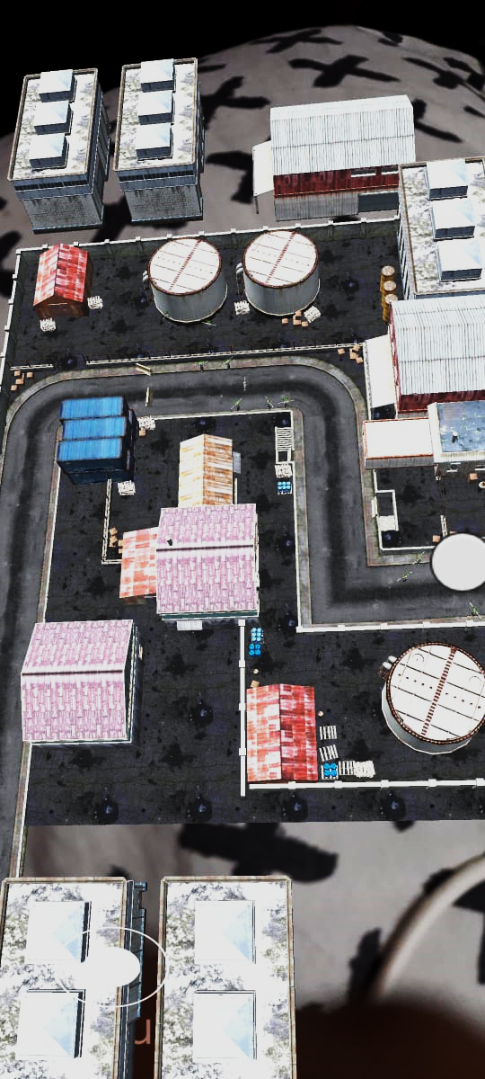



**Work left for completing the project:**

**As we have already developed game scene, player script and zombie script, and we have also combined them all together so that they can interact with one another. Now we just need to fix few errors and adjust the location of the joystick and attacking button and scale everything.**

**References:**

[**https://youtu.be/-FhvQDqmgmU**](https://youtu.be/-FhvQDqmgmU)

[**https://youtu.be/FF6kezDQZ7s**](https://youtu.be/FF6kezDQZ7s)

[**https://youtu.be/vApG8aYD5aI**](https://youtu.be/vApG8aYD5aI)

[**https://youtu.be/4HpC--2iowE**](https://youtu.be/4HpC--2iowE)

[**https://youtu.be/WdfStRynCLw**](https://youtu.be/WdfStRynCLw)

**Time required to complete project:**

**3-4 days**